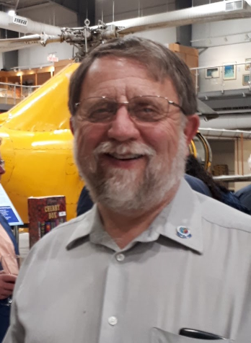
Greetings from the Rotary Club of Trenton! Please take some time to browse through our website, learn more about our club and see what our members are doing – both locally and internationally. Once you do, I think you will see that we are “People of Action”. If you have any questions just send me an e-mail.
If you’re interested in getting more involved in our community, making new friends and having some fun, the Rotary Club of Trenton might be just what you’re looking for.

Rotary is the largest service club in the world, consisting of approximately 1.2 million volunteers in over 200 countries. Rotary is where neighbours, friends and problem-solvers share ideas, join leaders and take-action to create lasting change. Through Rotary clubs, people from all continents and cultures come together to exchange ideas, and form friendships and professional connections while making a difference in their backyards and around the world.
You may be aware of some of the contributions and events organized by our club:
- The annual Surf & Turf, at the National Air Force Museum of Canada
- The Wilf Wilkinson Community Golf Classic
- Sponsoring the annual Phil Panelas BBQ in support of staff, volunteers and donors to the Trenton Memorial Hospital Foundation
- Our major President’s Legacy Project which will be unveiled later in 2018
You may also have seen the Rotary logo associated with countless other events and activities. But what you probably haven’t seen are the myriad community projects we support:
- Greening the Greenbelt shoreline habitat project with Lower Trent Conservation
- Youth Spelling Bee and Music Festival
- TMHF Banker’s Bed Races
- Assistance with funding of local youth centres
- EarlyAct clubs at Murray Centennial and Stockdale Public Schools
- Support for countless other projects and organizations that help and improve our community.
If helping others on the international level interests you, Rotary is also the place to be! Our club annually provides funding in support of an international project in literacy project Ethiopia, and works to support ShelterBox Canada, in their disaster relief efforts.
Fellowship and fun is also important, which is why we have so many fellowship events every year where we interact and just have some fun with fellow Rotarians. Whether it’s golfing with the President, SeptemberFest, Breakfast and Bows or just friendly get-togethers: Rotary is a great way to meet new friends and get together with existing ones.
I’ve only scratched the surface of what we do. So, if you want to help others, make new friends and get more involved in our community, please contact me and you can join us as our guest at one of our weekly meetings.

Frank Meiboom

